Northeast Colorado Creation Group
Hosting: Richard Cloud
From: Pikes Peak Creation Fellowship
PikesPeakCreation.org
Thursday, Oct. 7, 2021 @ 7- 8:30 PM
Berean Bible Church --211 West Beaver-- Fort Morgan
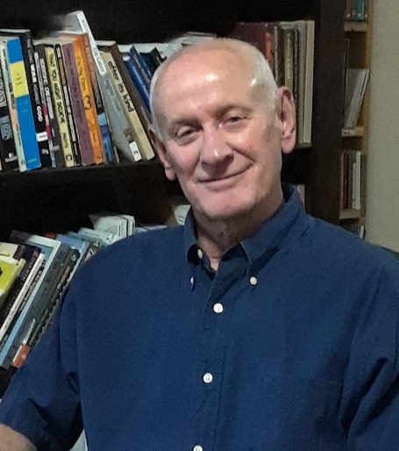

Examining the Factual Truth for “the One & Only”
(Biblical) Ice Age

- Why is the Ice Age important to us TODAY?
- What started the Ice Age?
- Could the Ice Age happen again?
- Is the Ice Age mentioned in the Bible?
- What was the impact on man and beast during the Ice Age?
- What happened to the mammoths and dinosaurs?
- How did the Ice Age impact Northeast Colorado?

Join us for a fascinating presentation for all ages—
Bring the family!
For more information, contact Paul Feltz: paulfeltz@gmail.com or neccg.org
Show Me the Evidence!
Books and DVDs available for free checkout from our library.

