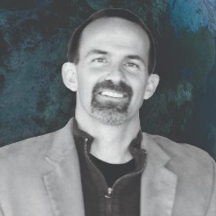
Northeast Colorado Creation Group
Hosting: Brian Young – creationinstruction.org
Thursday, Jan. 13, 2022 @ 6:30-8 PM
Berean Bible Church --211 West Beaver
Fort Morgan

Have you ever WONDERED?

- How could people live to be 900 years old?
- What about Carbon dating?
- Did dinosaurs live with man?
- Where did Cain get his wife?
- What about Cave men & the Bible?
- How can we raise our children in today’s society?

Join us for a fascinating presentation for all ages—
Bring the family. >>>Kid Friendly!<<<
Creation Science on Display
Evidence
For more information, contact Paul Feltz: paulfeltz@gmail.com or neccg.org
Books and DVDs available for free checkout from our library.

