Northeast Colorado Creation Group
NECCG will host:
Brian Mariani from:
Alpha Omega Institute
http://www.discovercreation.org/
Thursday, March 11, 2021 @ 7-8:30 PM
Berean Bible Church; 211 West Beaver – Fort Morgan
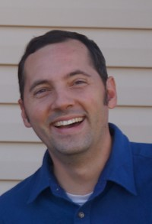
Engaging our Culture
Reaching people with Evidence and the Gospel

- Confusion and misinformation!
- What is relevant?
- Is there anything, that is absolute?
- How are we to think?
- ----“What is truth?”----
neccg.org
For more information, contact Paul Feltz at paulfeltz@gmail.com

