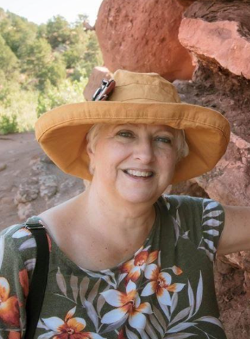
Teaching Biblical Creation in an Evolution-Focused Museum
Northeast Colorado Creation Group
Hosting:
Kate Warren
Teaching Biblical Creation in an Evolution-Focused Museum
Thursday, March. 10, 2022 @ 6:30-8 PM
Berean Bible Church --211 West Beaver
Fort Morgan

Who’s Afraid of the Big Bad Wolf!
Bill

- Billions or Thousands of Years?
- Goo to You? Really?
- “Birds come from dinosaurs”. What say???
- How does she get by teaching there?
- Dinos, dragons, and un-fossilized bones?
- Can I apply the 1 Peter 3:15 principle in a museum?

Join us. Get the answers to these questions.
Bring the family. >>>Kid Friendly!<<<
Books and DVDs available for free checkout from our library.
Creation Science on Display
Evidence
For more information, contact Paul Feltz: paulfeltz@gmail.com or neccg.org

