Northeast Colorado Creation Group
Hosting: Marcia Washburn
From: Building Tomorrow’s Generation
http://www.MarciaWashburn.com
Thursday, Sept. 16, 2021 @ 7- 8:30 PM
Berean Bible Church --211 West Beaver-- Fort Morgan
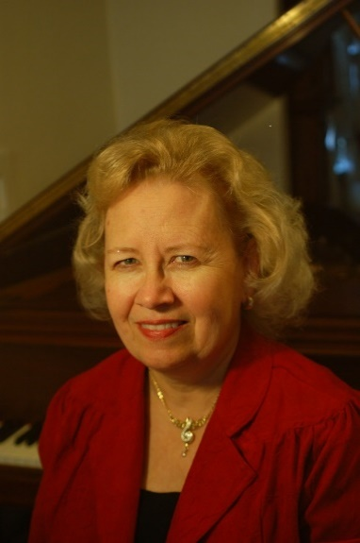
“... fearfully and wonderfully made.” Psalm 139:14a

Do you ever wonder. . .
[] Exactly how your body feeds and protects its 75 trillion cells?
[] Why the acids in your stomach don’t eat a hole in it?
[] How blood cells illustrate important Biblical teaching?
[] How your fingers move, despite having no muscles?
[] Which muscle and which bone in the body are strongest? You’ll be surprised.
Join us for a fascinating presentation for all ages—
Bring the family!
For more information, contact Paul Feltz: paulfeltz@gmail.com or neccg.org
Show Me the Evidence!
Books and DVDs available for free checkout from our library.

